## horizontal line

## 

## 

**CodeCanvas**

**Week 4**

**Video Editing in Design**

**29 December 2023**

# 

# 

# 

# 

# Overview

After working on still images and vectors, you can use them or create motion graphics for your resume. Premiere Pro is the tool you are looking for. It is the most versatile and sought-after software used to edit videos. We will learn it while making videos you can place in your portfolio. Adobe Premiere Pro is a great video editing tool. It's easy to use, works well with other Adobe apps, handles different video formats, and has cool features like changing colors. Whether you're a beginner or an expert, it helps make your videos look fantastic.

# Goals

Our main goal will be to make a professional commercial for a trekking company targeting an audience that wants to get lost in the tranquility of nature. You are given the stock footage, the logo of the company, and all the creative freedom to make the commercial.

Access the stock footage and the logo through this drive link: [Adventure INC](https://drive.google.com/drive/folders/1oLQpIhxvosXf2ZllpiY-wwqgBafrcN9L?usp=sharing)

**While making this commercial, we will be learning the following concepts:**

* **Scripting**
* **Sequencing**
* **Transitions**
* **Typography**
* **Audio**
* **Final Exporting and compression**

# Getting Started

## Software Setup and Beginner Tips

* First, you must install Adobe Premiere Pro on your systems. The following link will provide you with the download link of the software: [Adobe Suite](https://drive.google.com/drive/folders/1pjPehttM-Oz_D0KSdj4ZOzJ8VZRpi7Nt)
* Next, you need to know the different windows of the software and learn their functions. You can refer to video #1 from the playlist provided in the resources below to learn these.

Rendering your Final Output

* After all the editing, you must export the final video in a suitable audio format to present it.
* You can learn to export from the last video (video #12) from the playlist.

# Lessons

## Scripting

Now, you can get into the software and add clips to the sequence, but that will lead to some confusion as the project becomes bigger and bigger. So, the key to easy editing is scripting. It is super important in video editing because it helps plan the video, making it easier to choose the right shots quickly. It also makes sure that the video has a consistent style and story. The script will guide you in deciding how the video should flow. It's like a roadmap that keeps things organized but lets you be creative and make changes as needed.

After you have completed the scripting, you can start with your project. You can learn to set up your project here: [Video Details & Project Window - Adobe Premiere Pro CC Class 2 - Urdu / Hindi](https://www.youtube.com/watch?v=TP8wre-Mm1k&list=PLwL-0_HwdoybUKKN49hKdeWGt18acN1hN&index=1)

We have made a reference video while implementing all the lessons. The reference image after doing this step is given below:

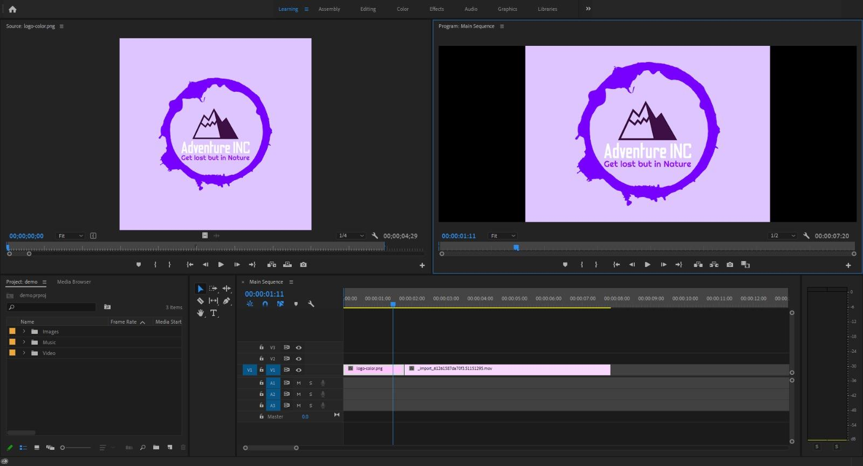

## Sequencing

Sequencing in video editing is like putting together puzzle pieces to tell a clear and engaging story. It's about deciding which shots come first and second to make the video sense and keep people interested. The order of scenes affects how the video feels—whether it's exciting, emotional, or calm. Smooth transitions between shots help everything flow nicely. Sequencing is like arranging the scenes in a book to create a good, easy-to-follow story that people enjoy watching.

You can learn to add sequences to your project here: [New Sequence and Timeline - Adobe Premiere Pro CC Class 4 - Urdu / Hindi](https://www.youtube.com/watch?v=2TyL6ViQDwQ&list=PLwL-0_HwdoybUKKN49hKdeWGt18acN1hN&index=2)

[Selection and Track Selection Tools - Adobe Premiere Pro CC Class 5 - Urdu / Hindi](https://www.youtube.com/watch?v=wDbosNeayeA&list=PLwL-0_HwdoybUKKN49hKdeWGt18acN1hN&index=3)

[Rate Stretch Tool - Adobe Premiere Pro CC Class 7 - Urdu / Hindi [Eng Sub]](https://www.youtube.com/watch?v=t--TP6YcI7Q&list=PLwL-0_HwdoybUKKN49hKdeWGt18acN1hN&index=4)

The reference image after doing this step is given below:

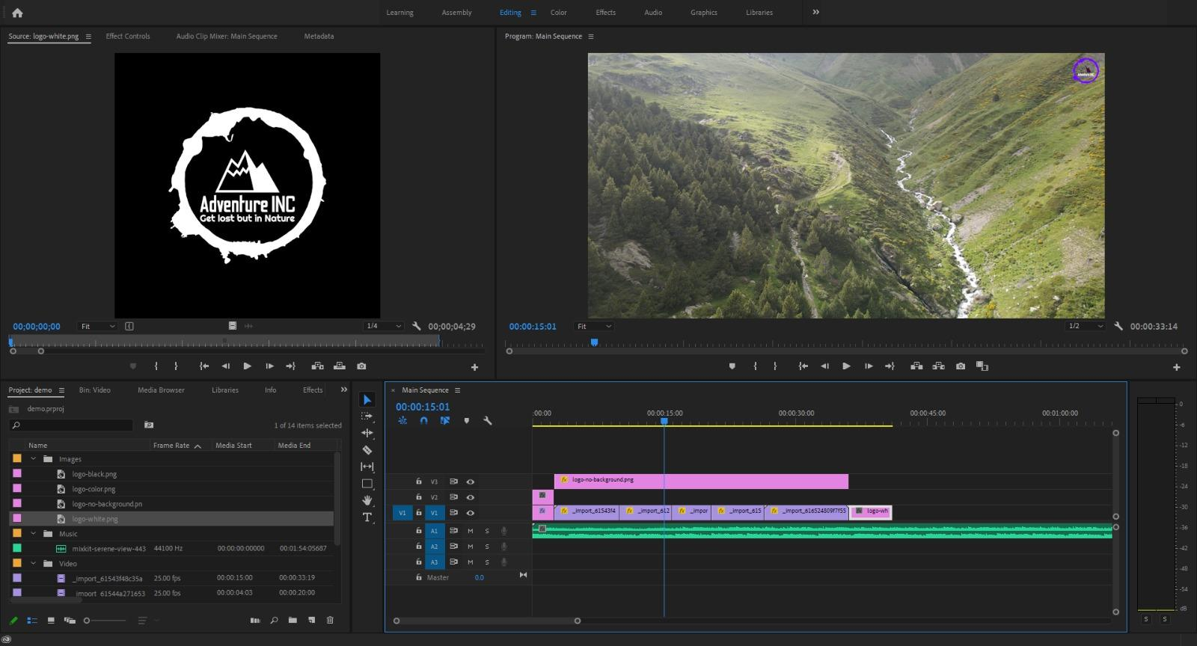

1. Transitions

Transitions in video editing are like smooth connectors between different video parts. They help the scenes flow seamlessly from one to the next, making the video look polished. Whether a quick cut or a gradual fade, transitions ensure the changes between shots are easy on the eyes and don't distract the viewer. They're like magic tricks that keep the story moving without bumps or jumps.

You can learn to add transitions to your project here:

[Transitions - Adobe Premiere Pro CC Class 10 - Urdu / Hindi](https://www.youtube.com/watch?v=_cH9wCi4Ihg&list=PLwL-0_HwdoybUKKN49hKdeWGt18acN1hN&index=6)

[Motion Effect Controls - Adobe Premiere Pro CC Class 11 - Urdu / Hindi [Eng Sub]](https://www.youtube.com/watch?v=LN7LeeJReXQ&list=PLwL-0_HwdoybUKKN49hKdeWGt18acN1hN&index=7)

The reference image after doing this step is given below:

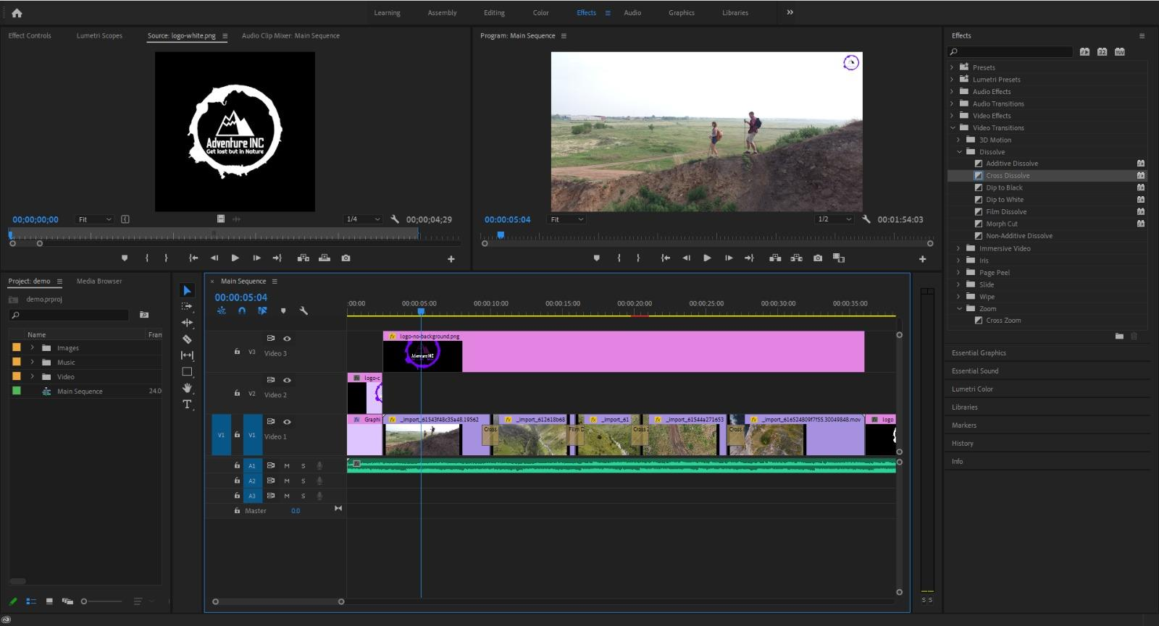

1. Typography

Typography in video editing is all about using text to convey information and enhance the video's visual appeal. It includes titles, captions, and subtitles that appear on the screen. You can choose different fonts, colors, and styles to make the text look good and fit the overall tone of the video. The goal is communicating messages, identifying speakers, and guiding the viewer without distraction. Good typography in video editing can grab attention, highlight important details, and make the viewing experience more enjoyable.

You can learn to use the type tool here: [Type Tool - Adobe Premiere Pro CC Class 16 - Urdu / Hindi](https://www.youtube.com/watch?v=eLjusyZM5Ss&list=PLwL-0_HwdoybUKKN49hKdeWGt18acN1hN&index=10)

[Rolling Credits - Adobe Premiere Pro CC Class 17 - Urdu / Hindi](https://www.youtube.com/watch?v=GTonBMRYAz8&list=PLwL-0_HwdoybUKKN49hKdeWGt18acN1hN&index=11)

The reference image after doing this step is given below:

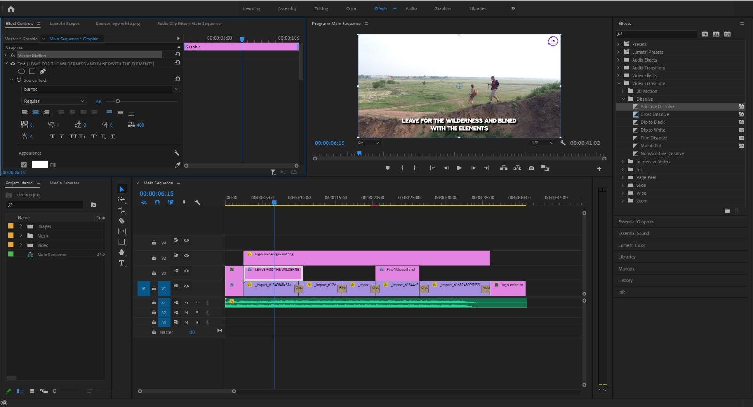

1. Audio

Audio in video editing is like the soundtrack of a movie—it includes everything you hear. This involves ensuring the volume is right, adding background music, and incorporating sound effects. The audio should synchronize with the video. You can also use tools to remove unwanted background noise and apply effects for creative purposes. Good audio enhances the overall quality of the video and makes the viewing experience more engaging.

You can learn to add audio and render your project here: [Export / Render Video - Adobe Premiere Pro CC Class 20 - Urdu / Hindi](https://www.youtube.com/watch?v=61NFKCDqXpw&list=PLwL-0_HwdoybUKKN49hKdeWGt18acN1hN&index=12)

1. Final Export

The final export in video editing is the last step, where the edited video is saved as a separate, standalone file. It's like putting together all the changes, edits, and enhancements made during the editing process into one complete video. During the export, choose the file format, resolution, and other settings to ensure the video looks and sounds how you want it to.

The final rendered video for reference is provided here: [Video for Reference](https://drive.google.com/file/d/1DEI_gcbOTd0OtrXmwOYEGGLu_tTCJ_v2/view)

# Resources

These are the resources you will need to learn some of the basics of the software.

Download Premiere Pro: [Adobe Suite](https://drive.google.com/drive/folders/1pjPehttM-Oz_D0KSdj4ZOzJ8VZRpi7Nt)

Playlist link for learning Premiere Pro: [Learn Premiere Pro](https://www.youtube.com/playlist?list=PLwL-0_HwdoybUKKN49hKdeWGt18acN1hN)

* Starting Premiere Pro, you will have to get accustomed to the user interface and its features: Video #1
* Next, you must learn how to add sequences and clip them from Video #2-4
* After that, add transitions and typography, as shown in Videos #6, 7, 10, and 11.
* The last step will be to add the audio and then export the final result, for which you can watch Video #12.

# Submission

You must submit your final commercial in **.mpeg** format and the Premiere Pro Project file in proper format (**.prproj**) in a Google Drive folder with all the access appropriately given.

A **Google form** will be shared with you through email, where you will be submitting your creations.